**Functional Document**

|  |  |
| --- | --- |
| **Application** | NGERP - Centra |
| **Service Bundle** | Sales Management |
| **Service Request** | Payment |

**Description :**

Payment screen is used in region to make payments to AR invoices. User can allocate the payment and invoice to confirm that business partner is paid the invoice amount. Payment can be made fully or partially by the partner. Once the payment is allocated the allocation is created and user can view the allocation in allocation tab for the payment.

**Workflow Process :**

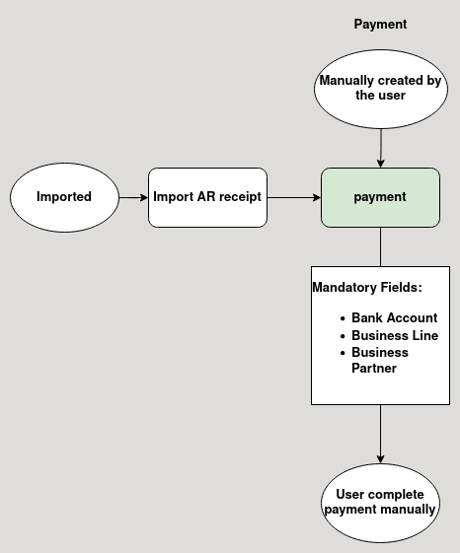

**Business Rules :**

* Document types that shows in Payment screen are:
  + AR receipt
  + Net off receipt
  + inter branch receipt
* AR receipt:
  + It is used to pay for promotion invoice
* Netoff receipt:
  + It is used to pay for payment netoff invoice
* Payment can be both imported and manually created in region.
* Payment is imported from Payment AR receipt screen.
* The payment amount cannot be entered negative in the payment screen.
* User can enter Zero in the payment screen.
* User cannot able to change the curreny in payment screen.
* User cannot able to void completed payment in payment screen.
* After Payment is completed it is loaded in loaded in Payment Allocation form.
* User can able to void completed payment in super payment screen.
* User cannot able to void the document if the payment is allocated.
* After payment is allocated wih invoice the allocation is shown in the allocation tab of payment screen.